Homemade Equipment and Workouts Using Items in Your House

If you do not have access to a ball, hoop, bat or sports equipment at home, no problem! Learn how to make sports equipment at home with these easy steps!
First things first, ask for permission and/or help when making some of this equipment, or before using items from your house. Remember, the activities provided are for all ability levels. Be sure to choose activities that are challenging and fun, yet safe for you. Also make sure you have enough space to exercise and play so that you are safe. Most importantly, have fun!

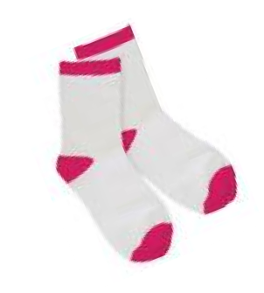
DIY BALL IDEAS:

Sock Ball  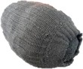 | Paper & Tape Ball  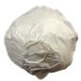 | Cotton Ball & Tape Ball  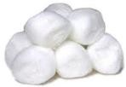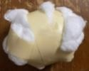
Pillow Case Ball  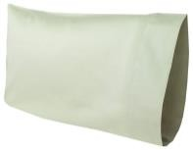 | Grocery Bag Ball  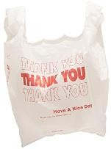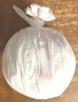 | Rubber Band Ball  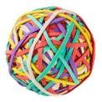
Balloon | Stuffed Animal  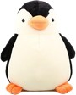 | Roll of Toilet Paper  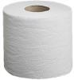
Aluminum Foil Ball

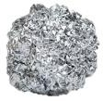

How to Make the Grocery Bag Ball:
Materials:
- Grocery bags (the more grocery bags you use, the larger and sturdier your ball will be!)

Instructions:
- Take one grocery bag and roll it into a ball
- Take another grocery bag and stuff your rolled grocery bag into this bag
- Roll the grocery bags into a ball
- Take another grocery bag and stuff your rolled grocery bags into this bag
- Continue this process for as many grocery bags as you’d like to use
- Take the handle ends of the grocery bag and tie a knot where the “ball” starts
- You can either keep the handles attached and use them for catching and tossing, or take scissors and cut them off at the top of the knot
- You can use this ball for a variety of throwing/tossing games and it is sturdy enough to use for gentle kicking games

How to Make the Paper Plate Racket & Tape Ball:
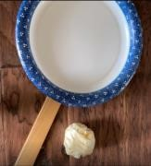
Materials:
- Sturdy paper plate (or a piece of cardboard)
- Masking/duct tape
- Ruler (or a cooking spatula, stick, paper towel roll, etc.)

Instructions:
- Rip off three medium length strands of tape and set them aside
- Turn your paper plate over so that the back side is facing up
- Place your ruler (or other object for the handle) in the middle of the plate, giving yourself enough of a handle to hold
- Place the three pieces of tape across your handle to secure it to the plate
- For the tape ball, roll up a piece of paper. If you want a larger ball, add another piece of paper to the outside of the ball and roll it up. Continue adding paper until you have the size you want.
- Wrap strands of tape around the paper ball until it is secure and round
- You can use this racket to play volleying games like badminton or challenge yourself and see how many times you can hit the tape ball before it hits the ground!

How to Make the Pillow Case Ball:

Materials:
- Pillow case
- Sock balls (or other clothing like t-shirts to ball up and put in. Just remember you’ll need to put your clothing away once you’re done!)

Instructions:
- Take your pillow out of the pillow case
- If your socks aren’t already made into sock balls, make your sock balls
- Fill your pillow case with the sock balls
- Push all of the sock balls into a bottom corner and round out the pillow case
- Take the end of the pillow case and make a knot where the “ball” starts
- Fluff and round out your ball
- You can use this ball for a variety of throwing games and it is sturdy enough to use for gentle kicking games. Be careful not to trip on the pillow case tail

How to Make the Sock Ball:

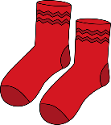
Materials:
- Long or short pair of socks (if you want multiple sock balls or to make one larger sock ball you will need more pairs of socks)

Instructions:
- Hold your socks so that they are apart and the top ends are touching
- Open up the top of one of the socks
- Fold over the end of the sock you have opened so that it goes down and around both socks towards the toes of both socks
- Stuff the toes of the socks up inside
- Mold your socks into a ball
- If you want a larger sock ball, make another one and stuff it inside the first one you made
- You can use this ball for a variety of throwing/tossing/rolling games and it is sturdy enough to use for gentle kicking games

